Meadowsweet *Filipendula ulmaria*

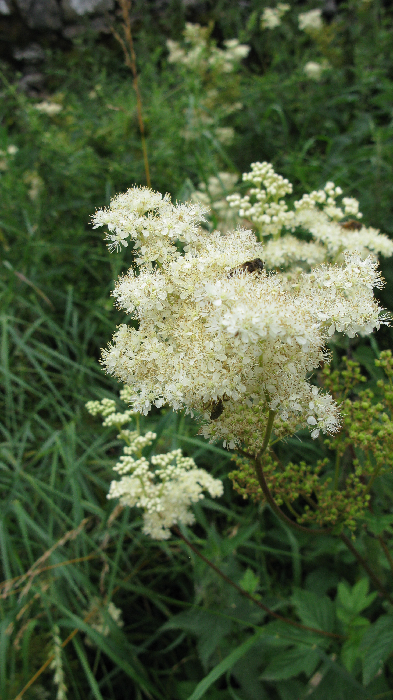

* Meadowsweet was one of the three herbs held most sacred to the Druids (Vervain and Water-mint being the other two).
* It was one of the fifty ingredients in a drink called 'Save' in Chaucer's 'Knight's Tale', where it was called Medwort or Meadwort.
* It was also a popular Elizabethan strewing herb, strewn on the floor in houses and churches both for warmth and to make a pleasant smell

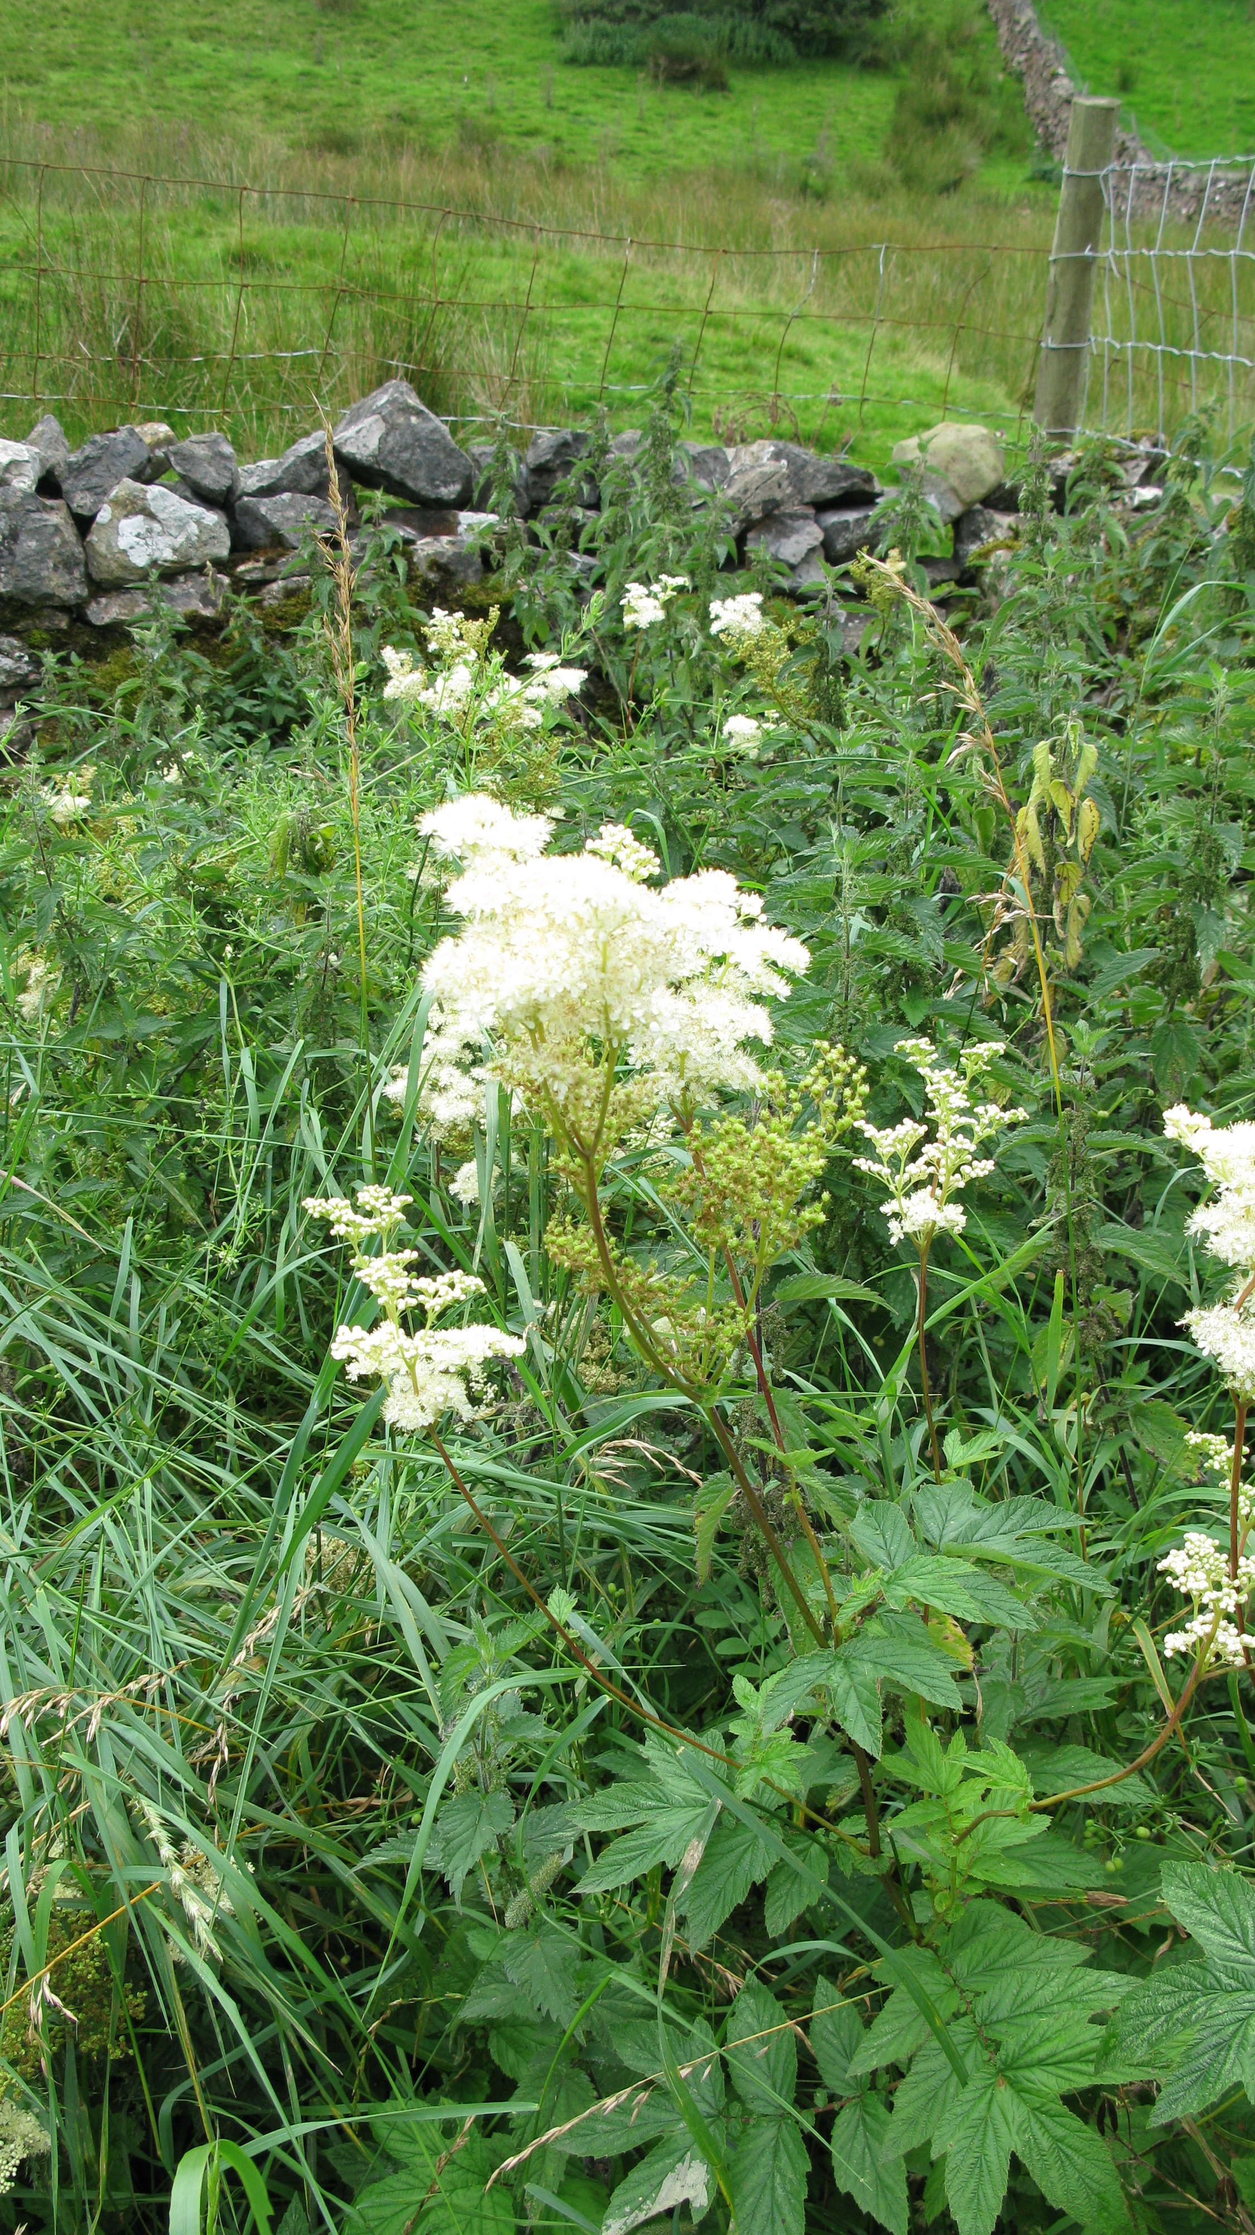

* In 1838 the Italian Rafaele Piria first produced salicylic acid from the flower buds of meadowsweet and from willow bark (*Salix alba*). In1897 Hoffman created acetylsalicylic acid from salicylic acid and found that it caused less stomach upset than the parent compound. Hoffman’s employer the drug company Bayer AG marketed this new drug calling it aspirin.
* Aspirin was named after the old botanical name for Meadowsweet *Spiraea ulmaria*

[a *Spir(aea)*in]

* In current herbal practice Meadowsweet is used in the treatment of heartburn, hyperacidity, gastritis and peptic ulceration.
* The anti-inflammatory action of the salicylates in meadowsweet makes it effective against rheumatic pain while the tannins and mucilages appear to buffer the adverse effects of isolated salicylates.
* Meadowsweet is used as a supportive treatment for common colds as the salicylic acid acts to reduce fever.